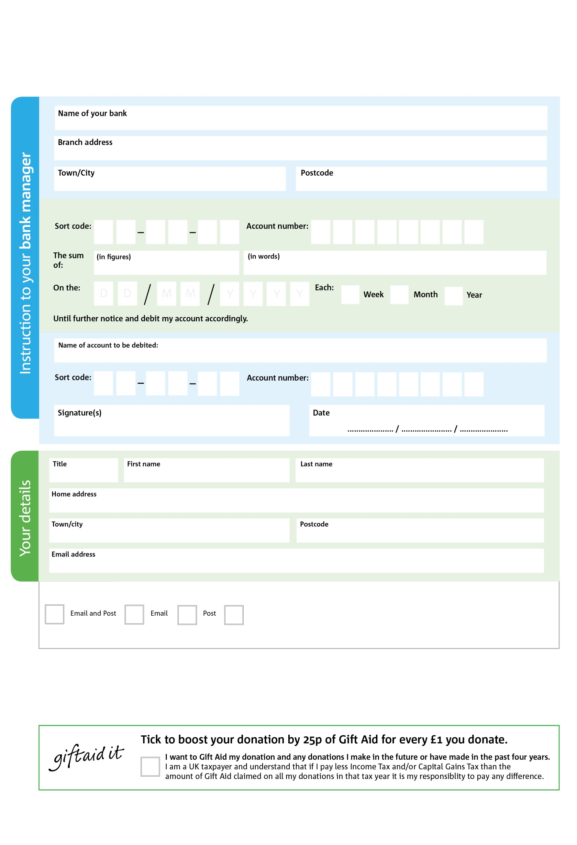

Reg. Charity No: 1134706 | Reg. in England & Wales

POSTAL ADDRESS: Taff-Ely Foodbank, c/o Bethel Baptist Church Centre, Heol Miskin, Pontyclun, RCT, CF72 9AJ

0

V

6

V

0

V

5

V

4

V

7

V

9

V

3

V

**Please pass this form onto the foodbank, using the foodbank’s address at the bottom, who will save a copy for their records.   
They will then send it onto your named bank or building society.**

4

3

7

6

0

3

We would love to keep you up to date with information about Taff-Ely Foodbank. Please tick your preference:

You can change your preferences any time by contacting us on 07871 552804 or emailing us at andrewbutcher@taffely.foodbank.org.uk

I do not wish to receive future communications from Taff-Ely Foodbank

Please pay Taff-Ely Foodbank,

**Data protection**

*‘Taff-Ely Foodbank is committed to protecting your privacy and will process your personal data in accordance with current Data Protection legislation. Taff-Ely Foodbank collects information to keep in touch with you and supply you with information relating to our work. To unsubscribe from our newsletter, send a message to the email address above with the word unsubscribe in the subject line. A full data privacy statement for financial donors is available from the foodbank on request.’*

**Standing Order Mandate**

**taffely.foodbank.org.uk**

You can change your preferences any time by contacting us on XXXXXXXXXXX or emailing us at XXXX@XXXXXXXXXX.foodbank.org.uk

I do not wish to receive future communications from XXXXXX Foodbank