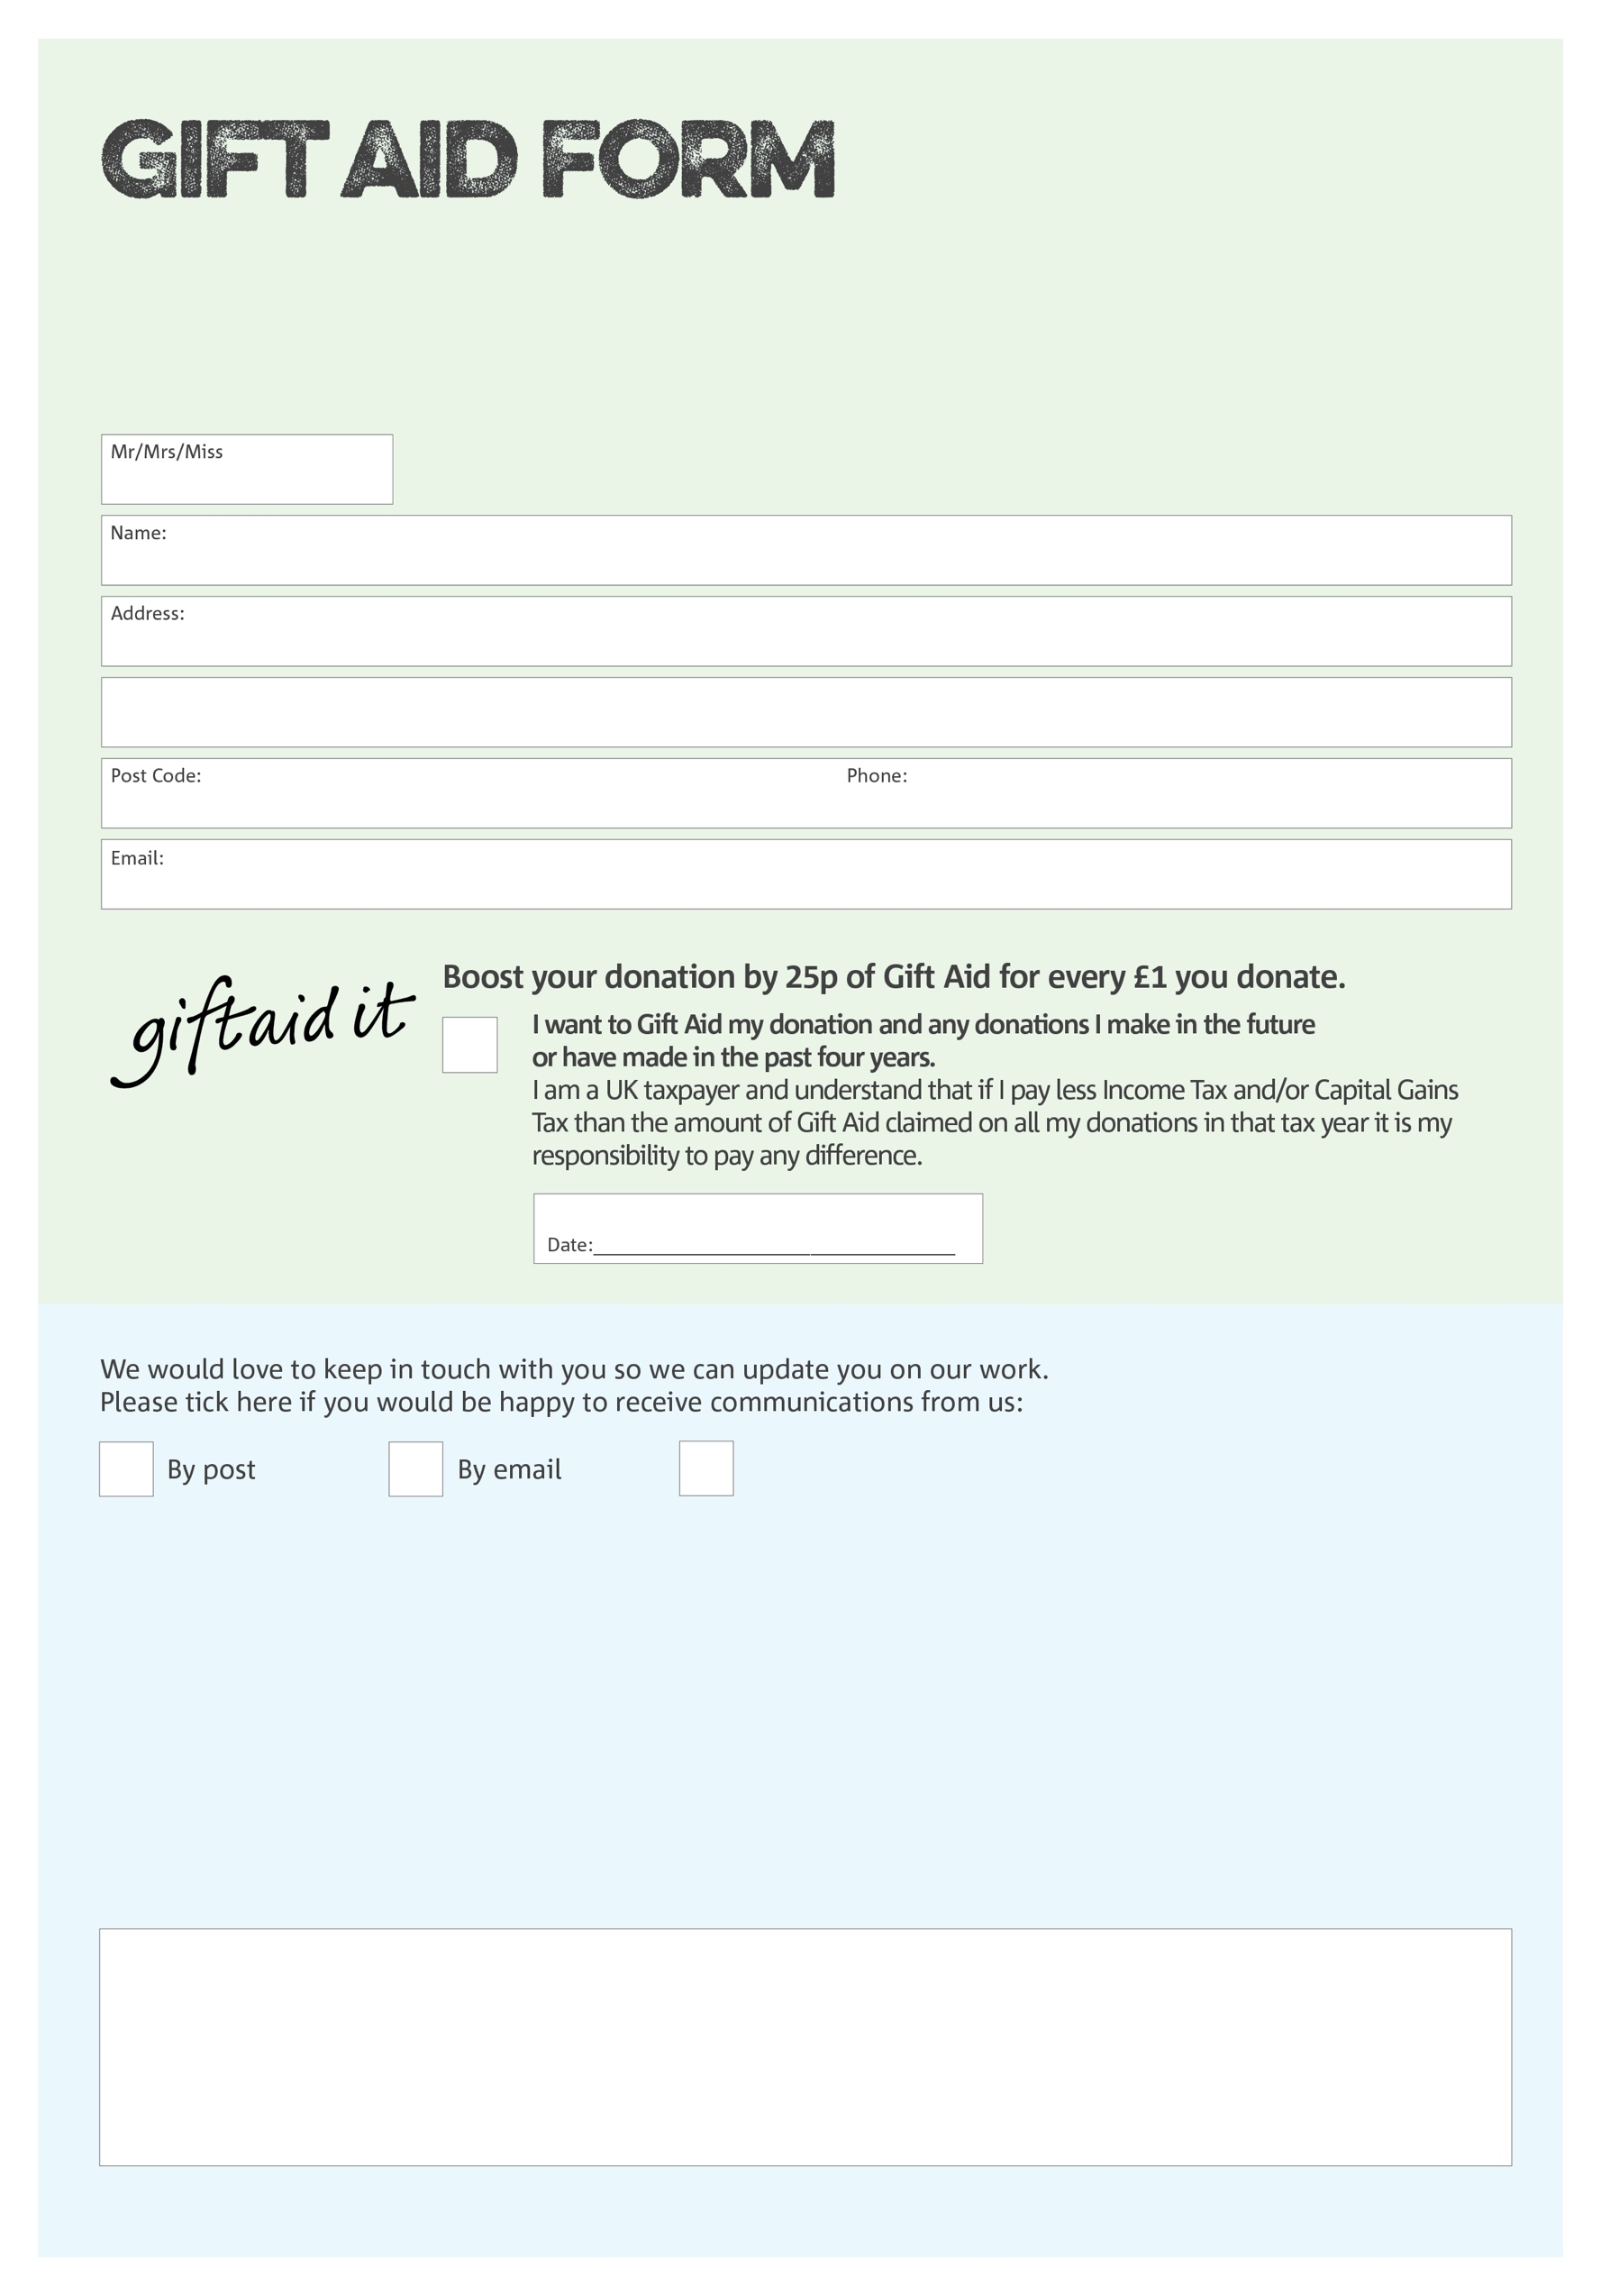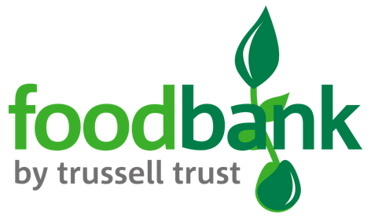

By filling in this form Taff-Ely Foodbank will receive an extra 25p for every £1 you give at no extra cost to you. Thank you!

**Data protection**

*'Taff-Ely Foodbank is committed to protecting your privacy and will process your personal data in accordance with current Data Protection legislation. Taff-Ely Foodbank collects information to keep in touch with you and supply you with information relating to our work. To unsubscribe from our newsletter, send a message to the email address above with the word unsubscribe in the subject line. A full data privacy statement for financial donors is available from the foodbank on request.’*

You can change your preferences any time by contacting us on 07871 552804 or emailing us at

andrewbutcher@taffely.foodbank.org.uk

I do not wish to receive future communications from Taff-Ely Foodbank

We would love to know why you have chosen to donate to Taff-Ely Foodbank. If you would like to share your motivation let us know below:

Charity Number 1134706. Registered in England & Wales